**Star Crusher Building Instruction Effectiveness and Feasibility**

INTRODUCTION

**Purpose**

The purpose of this report is to analyze the feasibility of the Star Crusher Paper Airplane instructions and present findings to the Ames Middles School science staff.

**Problem**

Students of local Ames Middle School currently do not have physical tools that help students understand basic aerodynamic concepts for lessons in science class. The students must be able to set-up, build, and clean-up from the visual aid in no more than one 40-minute class. With the primary function of the Star Crusher being to aid in teaching aerodynamic concepts to the students, it is important that the students use the remaining classes during the week to discuss the aerodynamic concepts.

The presented solution involves using the Star Crusher plane building instructions to help students create their own visual aid. The Star Crusher would be used as a visual aid for the subsequent lessons throughout the week.

**Scope**

The Star Crusher plane is a futuristic-looking paper plane with instructions containing 43 individual steps. The instructions will be evaluated based on build time, flight distance, durability, and difficulty indicated by 13 individual university students.

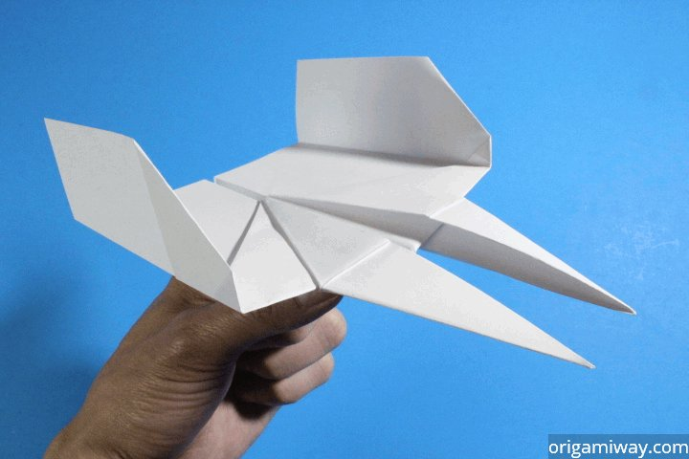

**Figure 1**

*Star Crusher paper airplane*

*Source: Origami Way, Star Crusher Paper Airplane*

DISCUSSION

**Build Time**

*Explanation*

The build time of the Star Crusher is critical for this application because of the 40-minute time constraint that has been set.

*Data*

**Table 1** Build Time (T) vs. Sample (S)

|  |  |  |  |  |  |  |  |  |  |  |  |  |  |
| --- | --- | --- | --- | --- | --- | --- | --- | --- | --- | --- | --- | --- | --- |
| **S** | 1 | 2 | 3 | 4 | 5 | 6 | 7 | 8 | 9 | 10 | 11 | 12 | 13 |
| **T** | 8:44 | 16:12 | 10:30 | 8:49 | 12:18 | 11:46 | 9:19 | 18:37 | 12:09 | 8:58 | 11:29 | 13:41 | 15:03 |

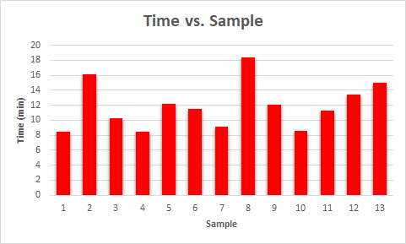*Interpretation*

Based on the data collected during our testing, it was found that the overall build time is feasible for a 40-minute class period. Set-up and clean-up for the plane are very minimal because there are no leftover scraps from the paper airplane. The build times collected varied from around 9 minutes to 19 minutes with the average being 12 minutes and 7 seconds.

**Figure 2**

*Build time of each sample*

**Distance Flown**

*Explanation*

The objective of this lesson is to teach students the concepts of aerodynamics. Measuring the distance flown for each plane will determine if the plane can accurately show the aerodynamic concepts.

*Data*

**Table 1** Distance Flown (DF) vs. Sample (S)

|  |  |  |  |  |  |  |  |  |  |  |  |  |  |
| --- | --- | --- | --- | --- | --- | --- | --- | --- | --- | --- | --- | --- | --- |
| **S** | 1 | 2 | 3 | 4 | 5 | 6 | 7 | 8 | 9 | 10 | 11 | 12 | 13 |
| **DF** | 10 | 8 | 13 | 3 | 2 | 5 | 15 | 7 | 10 | 9 | 4 | 5 | 3 |

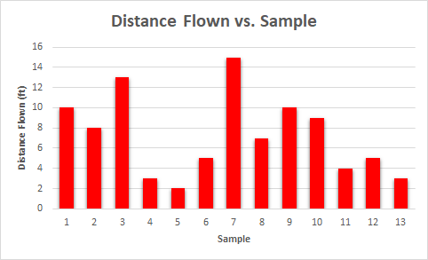*Interpretation*

Testing the samples revealed inconsistent flight distances. During the tests, the planes tended to deviate from a straight path. Deviation caused the planes to travel backwards in some cases leading to poor measured distances.

**Figure 3**

*Distance flown from each sample*

**Durability**

*Explanation*

Because the planes will be used throughout the week, the durability of the plane must be enough to withstand frequent use during the lessons.

*Data*

**Table 3** Drops Until Bend (DUB) vs. Sample (S)

|  |  |  |  |  |  |  |  |  |  |  |  |  |  |
| --- | --- | --- | --- | --- | --- | --- | --- | --- | --- | --- | --- | --- | --- |
| **S** | 1 | 2 | 3 | 4 | 5 | 6 | 7 | 8 | 9 | 10 | 11 | 12 | 13 |
| **DUB** | 3 | 1 | 2 | 2 | 3 | 5 | 6 | 1 | 4 | 2 | 4 | 1 | 3 |

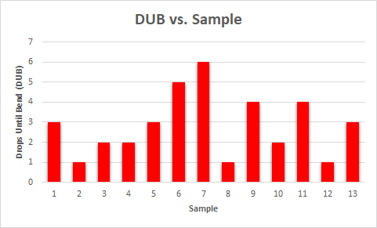*Interpretation*

When testing the durability several planes only withstood one drop before the nose bent. With standard use in class, the design will not hold up to repeated use. An average of just under 3 drops caused damage that inhibited flight.

**Figure 4**

*Durability testing using repeated drops*

**Difficulty**

*Explanation*

Lessons will be presented to middle schoolers with no real understanding of aerodynamics, and as such must be enough to capture interest, but simple enough to understand. The participants were asked to rate the level of difficulty in constructing the plane.

*Data*

**Table 4** Difficulty Rating (DR) vs. Sample (S)

|  |  |  |  |  |  |  |  |  |  |  |  |  |  |
| --- | --- | --- | --- | --- | --- | --- | --- | --- | --- | --- | --- | --- | --- |
| **S** | 1 | 2 | 3 | 4 | 5 | 6 | 7 | 8 | 9 | 10 | 11 | 12 | 13 |
| **DR** | 8 | 5 | 7 | 6 | 8 | 10 | 6 | 7 | 7 | 9 | 8 | 5 | 9 |

1 → Easy, 10 → Hard

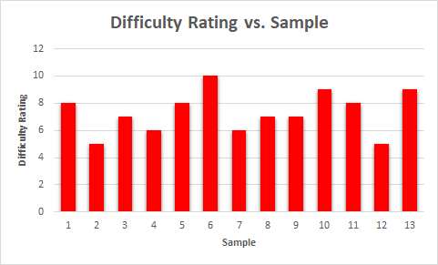*Interpretation*

The Star Crusher Paper Airplane having 43 steps of construction, was challenging to build for a majority of testers. The average difficulty given was 7.3 among the university aged samples.

**Figure 5**

*Level of difficulty reported after construction*

CONCLUSION

**Summary**

The data from our tests shows that the Star Crusher plane does not satisfy all requirements of the aerodynamic lesson. During testing, the plane was difficult to build, flew inconsistently, and was not durable enough for a classroom setting.

**Conclusions**

The Star Crusher Paper Airplane is not feasible for use in the lesson.

**Recommendation**

It is suggested that the class uses a plane that is not as complex as the Star Crusher and features better aerodynamic characteristics such as the Hammer Paper Airplane from Origami Way.

**Contact Information**

If there are any further questions regarding the findings of this report, please direct them to the individuals below:

Jack Larish - [jrlarish@iastate.edu](mailto:jrlarish@iastate.edu)

Ethan Piszczek - [piszczek@iastate.edu](mailto:piszczek@iastate.edu)

Spencer Snider - [sgsnider@iastate.edu](mailto:sgsnider@iastate.edu)

Sean Gordon - [sgordon@iastate.edu](mailto:sgordon@iastate.edu)